# The Village of Nelsonville Board of Trustees Meeting Minutes

**Monday, June 17, 2024**

The Village of Nelsonville Board of Trustees met at 7:30pm, on Monday, June 17, 2024, for their regular meeting, with Mayor Winward presiding, Trustees Anderson and Moroney present. Trustees Biro and Zhynovitch were absent.

# Approval of Vouchers

Abstract #1 in the amount of $42,140.56 was audited and ordered paid by a motion from Trustee Moroney, seconded by Trustee Anderson, carried three in favor, two absent.

# Approval of Minutes

The minutes of the May 20, 2024 regular meeting were approved by a motion from Trustee Moroney, seconded by Trustee Anderson, carried three in favor, two absent.

# Correspondence

Mayor Winward stated that the Village received six letters of thanks for the mayor taking a position regarding concerns about the Fjord Trail starting at Dockside.

**Reports**

Clerk Harris

In the absence of the clerk, the mayor read the Treasurers’ Report:

Village of Nelsonville

Treasurer's Report

31-May-24

***********************************************************************************************

GENERAL FUND

Previous Balance

$352,999.14

Receipts:

Total $7,460.86

Disbursements:

Total $30,222.53

Current Balance $330,237.47

Checking Account $330,237.47

Savings Account $127,484.66

  \

TOTAL $457,722.13

Mayor Winward

Mayor Winward reported that the Rockledge Cell Tower construction has begun, cutting through bedrock to lay utility lines. She stated the Building Inspector is checking in to make sure they are complying with boundaries. The mayor also reported that Wood Avenue resident Marc Kushner is again pursing a lawsuit against the Village and the former Building Inspector and former Planning Board Chair. She stated that the plaintiff has attempted to change the court venue to Westchester County, but that the insurance appointed lawyers are seeking to change to Putnam County, where the previous related lawsuits were heard and dismissed.

Trustee Moroney

Trustee Moroney reported that the highway crew is clearing roadside weeds, and that street lines have been painted. He stated that Central Hudson has taken down a tree that was threatening power lines, and he is hopeful that they will take down another tree.

**New Business**

Motion to Approve renewal of Village Attorney Agreement

Upon motion by Mayor Winward, seconded by Trustee Anderson, carried three in favor, two absent, the Village Attorney Agreement with Keane and Beane was approved.

RESOLUTION TO CONTINUE LEGAL SERVICES AGREEMENT WITH

THE LAW FIRM OF KEANE & BEANE FOR 2024-2025

WHEREAS, The Village Board of Trustees has been presented with a proposed letter of engagement from Keane & Beane P.C. for services as Village Attorney, for the year 2024-2025; and

WHEREAS, Keane & Beane has served the village well over the past year and the proposed contract contains the same rates and services;

NOW THEREFORE BE IT RESOLVED, That the Board of Trustees of the Village of Nelsonville authorizes the attached Letter of Engagement to be executed by the mayor with Keane & Beane P.C. for the Village of Nelsonville; and for the Village to appropriate funds in the amount stated in the attached contract for that purpose.

The foregoing resolution was voted upon with all members voting as follows:

Mayor Winward Aye

Trustee Anderson Aye

Trustee Biro Absent

Trustee Moroney Aye

Trustee Zhynovitch Absent

Motion to Approve Village Prosecutor Contract

Upon motion by Mayor Winward, seconded by Trustee Moroney, carried three in favor, two absent, the Village Prosecutor Agreement with Kevin P. Irwin, Esq. was approved.

RESOLUTION TO CONTINUE LEGAL SERVICES AGREEMENT FOR

VILLAGE COURT PROSECUTOR SERVICES 2024-2025

WHEREAS, The Village Board of Trustees has been presented with a proposed contract for a Village Court Prosecutor, Kevin P. Irwin, for the year 2024-2025; and

WHEREAS, Kevin P. Irwin has served the village well over the past year and the proposed contract contains the same rates and services;

NOW THEREFORE BE IT RESOLVED, That the Board of Trustees of the Village of Nelsonville authorizes the attached contract to be executed by the mayor with Kevin P. Irwin to investigate, prepare, and prosecute non-criminal violations for the village of Nelsonville as needed; and for the Village to appropriate funds in the amount stated in the attached contract for that purpose.

The foregoing resolution was voted upon with all members voting as follows:

Mayor Winward Aye

Trustee Anderson Aye

Trustee Biro Absent

Trustee Moroney Aye

Trustee Zhynovitch Absent

Motion to Approve Annual NYS Local Retirement System Standard Workday Resolution

Upon motion by Mayor Winward, seconded by Trustee Moroney, carried three in favor, two absent, the Annual NYS Local Retirement System Standard Workday Resolution was approved.

Motion to Re-Appoint Planning Board Members

Upon motion by Mayor Winward, seconded by Trustee Moroney, carried three in favor, two absent, Planning Board members Dove Pedlosky, David Herman, and Dennis Meekins were approved to be re-appointed.

**Old Business**

FEMA and Storm Repair Updates

Mayor Winward stated that the Hydraulic and Hydrology Analysis for Healy Road, which FEMA is requiring for hazard mitigation, is completed and been submitted to FEMA. She stated she believes the Village is on the final step for hazard mitigation approvals for Healy Road, Pine Street, and Bank Street.

NYSDOT Permit Updates for Speed Radar Signs and Flashing Crosswalk Updates

The mayor updated the board on the radar signs and flashing crosswalk signs, stating that Trustee Zhynovitch has been working on finalizing who will be installing the signs, and where the poles for the crosswalk signs will be sourced. The information is not yet completed for final submission to DOT.

NYSERDA CEC Grant Update

Mayor Winward stated that the Village has applied for and earned $10,000 from the NYSERDA CEC grant program. Of the pre-approved project list, the Village can complete an LED street light conversion of the remaining non-LED lights in the village. The mayor made a motion to approve spending $2,187.07 for the LED conversion, which was seconded by Trustee Moroney, carried three in favor, two absent. The mayor will see what else the Village is able to spend the remainder of the grant on.

Solar Panel Research

The mayor stated that Trustee Anderson would begin undertaking research into solar panels, and a cost analysis of the Village’s electric usage. She stated that one company came in for an estimate, and a quote will be coming. The mayor stated that it’s possible that Village Hall may not be a candidate for solar panels, due to roof size constraints and other factors. She explained that the federal ARPA funds need to be allocated by the end of December of this year, and solar was one possible project, but APRA funds can also be used for FEMA restoration and will be used for the crosswalk and speed signs.

Fjord Trail Updates

Mayor Winward stated that a letter went out on 5/21/24 from Amy Kacala to municipal leaders and Data Committee reps, explaining what the next phase of the committee will look like, and how seats would be redistributed. Nelsonville will only have one seat, down from two, and it was explained this was based on population. She stated that on 6/3/24, the Steering Committee met and discussed the upcoming closure of Breakneck Trail, which will be closed for 18 months beginning in November of 2024 for bridge construction. On 6/6, members of the Philipstown Data Committee gave a summary report of the committee’s work to date. On 6/17, the three municipal leaders had their monthly call with the Parks Department, during which they learned that the Breakneck Tunnel will be closed for construction from July to October, with one lane open to traffic. During construction no hikers will be allowed in the tunnel. The tunnel will be expanded to include a 5’ walkway on the river side, and traffic lanes will be shifted to the mountain side. A crosswalk will also be installed. The mayor expressed her concerns about increased parking issues in the Village due to the trail closures, and there was some discussion among the board regarding public announcements regarding the closures. The mayor stated that more “no parking” signs will be installed along the Nelsonville Woods side of Secor Street.

**Open to the Floor**

Rebecca Ramirez, Community and Visitor Relations Manager for the Hudson Highland Fjord Trail, answered questions from the board and an audience member regarding the Fjord Trail closures. Concerns were raised by the board regarding the lack of communication with elected officials in the villages and town.

# Adjournment

Trustee Moroney moved to adjourn the meeting, seconded by Trustee Anderson, carried three in favor, two absent. The meeting was adjourned at 8:45pm.

Respectfully presented,

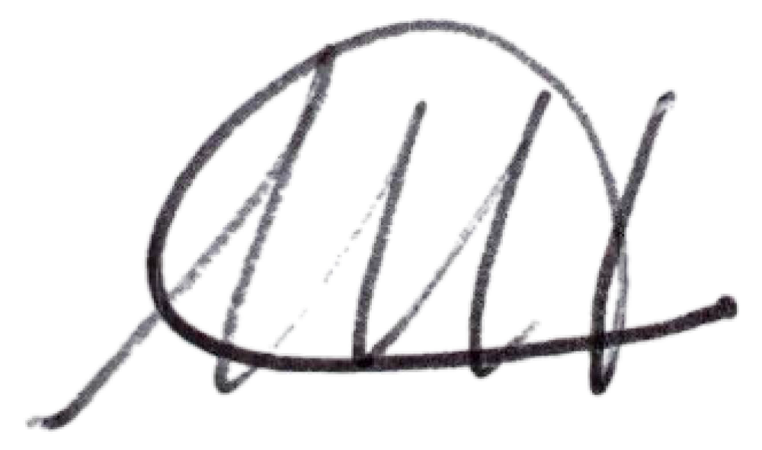

Melissa Harris

Village Clerk